**Part1: Bollinger Strategy Results**

*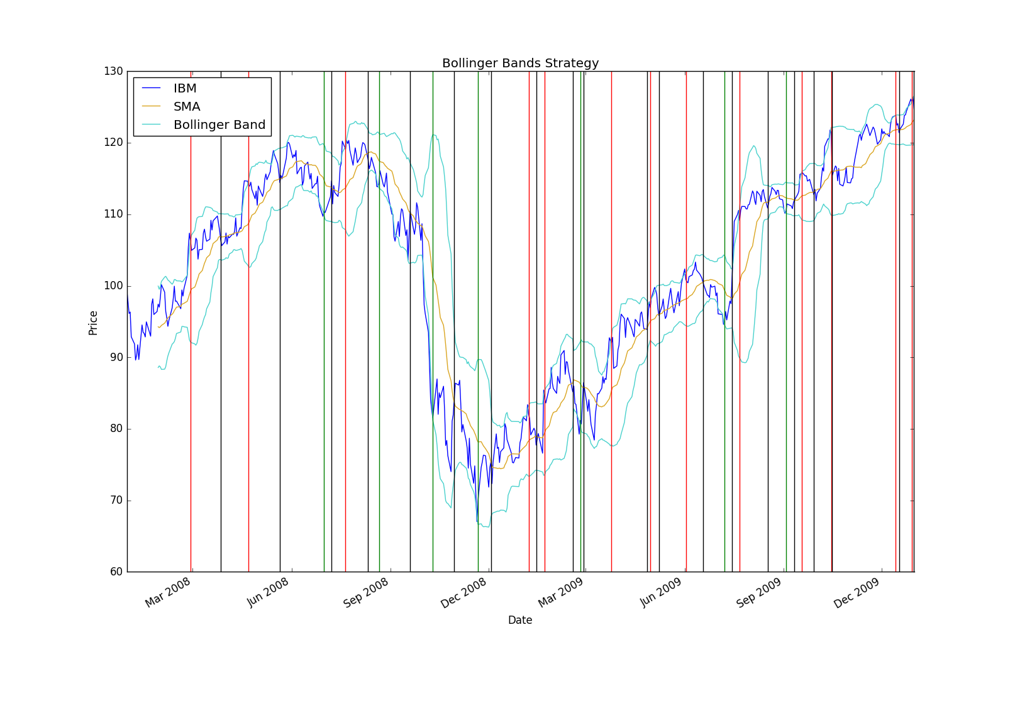Figure1: Bollinger Band strategy chart showing entry and exit points*

*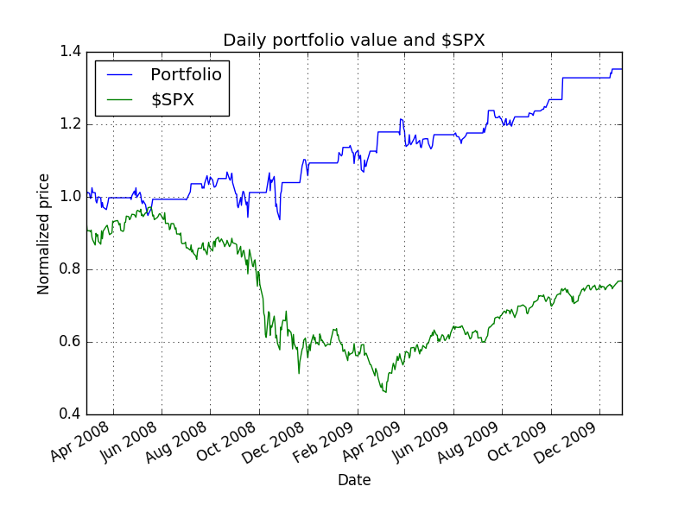Figure2: Bollinger Band strategy back test chart*

*Figure3: Summary of Bollinger Band back test performance metrics*

Date Range: 2008-02-28 00:00:00 to 2009-12-29 00:00:00

Sharpe Ratio of Fund: 1.00195922396

Sharpe Ratio of SPX : -0.116052774605

Cumulative Return of Fund: **0.3524**

Cumulative Return of SPX : -0.176561768835

Standard Deviation of Fund: 0.0113472713465

Standard Deviation of SPX : 0.0225771006222

Average Daily Return of Fund: 0.000716211380412

Average Daily Return of SPX : -0.000165053001441

Final Portfolio Value: **13524.0**

**Part 2: Student Strategy**

For my strategy, I decided to use the Kairi Relative Index [KRI] that I happened to stumble upon in Investopedia. As described in [1], the KRI is a Japanese leading indicator that indicates momentum oscillations and have been over shadowed by the Relative Strength Index. The way KRI is calculated is as follows:

100 x (Price – simple moving average)/(simple moving average)

The SMA could be over a period of 20 or 10 days and I have decided to go with 20 days. The main strategy that is used when employing this indicator is to sell if indicator is positive and to buy if the indicator is negative. Upon examining the graphs, I noticed that the strategy makes purchases when the overall stock is in an upward trend as you can see in the charts below.

To find the parameters of the graph, I’ve done some experimenting with the index, and I finally decided to do the following after calculating the KRI:

Long Entry: if KRI < -0.1

Long Exit: if KRI > 4.15

Short Entry: if KRI > -0.75

Short Exit: if KRI < 3.55

The main issue when calculating these parameters is that they were calculated for the in-sample period (2007-2009) so these parameters were biased towards that data set and it seemed that it was slightly overfit to produce the best result but I also made sure not to tweek it too much to the point that it gives me high accuracy in the (2007-2009) period and performs badly elsewhere. So to answer the question whether refining the strategy over the same period is good, I would definetly disagree due to the previously mentioned reason. As for the second part that relates to perfomance, I was surprised to see it perform quite good even in the latter period (2009-2011) and the reason could be that I did not tweak the paramaters so much for the period (2007-2009) so they were not that bias towards that period’s data.

The results of my strategy as compared to the Bollinger band strategy is as follows for both in sample and out of sample periods:

|  |  |  |  |  |
| --- | --- | --- | --- | --- |
|  | **In Sample between 2007 - 2009** | | **Out of Sample between 2009 - 2011** | |
| Strategy | Bollinger | My Strategy | Bollinger | My Strategy |
| Date Range | 2008-02-28 to 2009-12-29 | 2008-01-29 to 2009-12-07 | 2010-02-01 to 2011-11-30 | 2010-01-29 to 2011-12-19 |
| Sharpe Ratio of Fund | 1.00195922396 | 1.00122994864 | 0.427702655439 | 0.80060183179 |
| Sharpe Ratio of SPX | -0.116052774605 | -0.138096942031 | 0.454866937848 | 0.395948928815 |
| Cumulitive Return of Fund | **0.3524** | **0.4972** | **0.126** | **0.4048** |
| Std dev of fund | -0.176561768835 | 0.0155620032328 | 0.144850760657 | 0.01700556064 |
| Std dev of SPX | 0.0225771006222 | 0.0225369648463 | 0.0123726224413 | 0.01321372109 |
| Ave. Daily return of Fund | 0.000716211380412 | 0.0009815197944 | 0.000333352285 | 0.0008576444 |
| Ave Daily return of SPX | -0.00016505300144 | -0.00019605558 | 0.000380483034 | 0.00032958241 |
| Final Portfolio Value | **13524.0** | **14972.0** | **11260.0** | **14048.0** |
| My Strategy Performance | **(0.4972)/(0.3524) = 1.41089** | | **(0.4048)/(0.126) = 3.21269** | |

It can be seen above that my strategy was able to outperform the bollinger band strategy in both the in sample and out of sample periods.

*Figure 4*: *My strategy chart showing entry and exit points*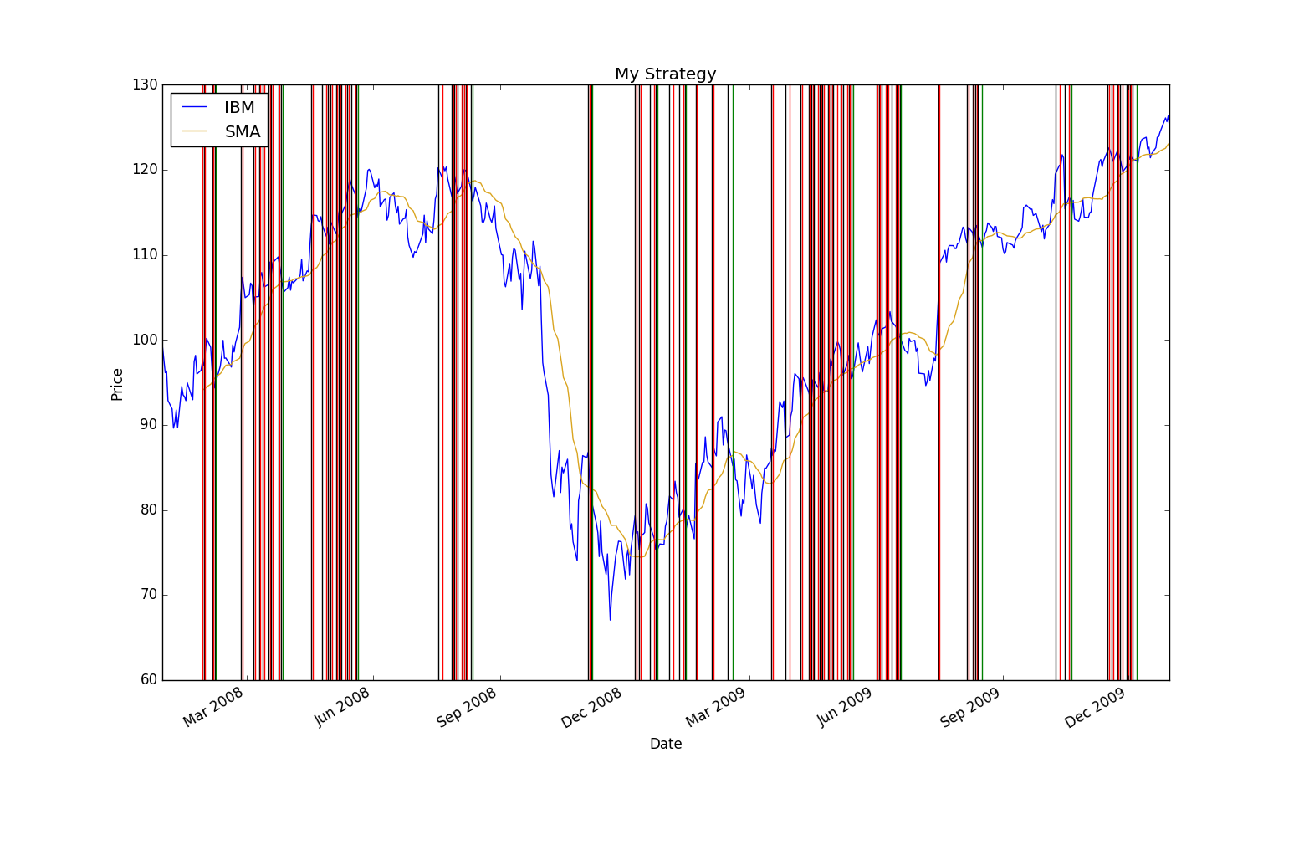

*Figure5: My strategy in Sample back test chart*

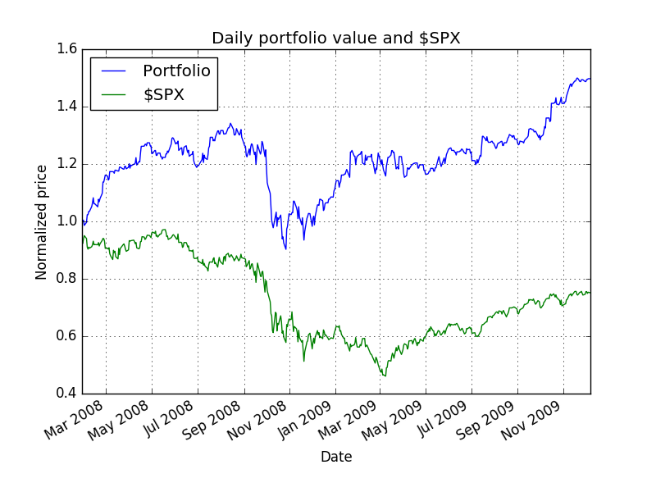

It can be seen here that the strategy is performing quite well with an upward trend away from SPX and not as much volatility. Also it has a cum. Return of 0.4972. This is quite understandable as the parameters were tweaked based on this period so it a bias is expected. It also outperforms the Bollinger band strategy by 1.4 as shown in the result table above.

*Figure6: My strategy out of Sample back test chart*

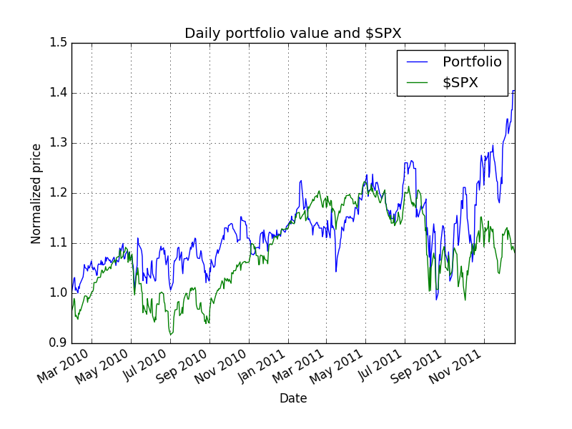

I

We can see in the chart above that my strategy does not perform as well when compared with the in sample period. It is more volatile with a trend that almost follows SPX except at the end where surprisingly increases while outperforming Bollinger bands by 3.2 as shown in the result table above and it also has a cum. Return of 0.4048. The volatility can be due to the parameters being tweaked for the in sample period and are not as applicable for this period.

**References:**

1. Kairi Relative Index: The Forgotten Oscillator | Investopedia. (2009). Retrieved March 26, 2016, from http://www.investopedia.com/articles/forex/09/kairi-relative-strength-index.asp
2. CS 7646: Machine Learning for Trading video lectures.
3. Pandas 0.18.0 documentation